Experiment No:9
AIM: To Implement Bezier Curve.
THEORY:
Bezier curves are widely used in computer graphics to model smooth curves. As the curve is completely contained in convex hull of its control points, the points can be graphically displayed and used to manipulate the curve intuitively. Affine transformations such as translation, scaling and rotation can be applied on the curve by applying the respective transform on the control points of the curve. The mathematics of these curves is classical, but it was a French automobile engineer Pierre Bezier who introduced their use in computer graphics.
Quadratic and cubic Bézier curves are most common; higher degree curves are more expensive to evaluate. When more complex shapes are needed, low order Bézier curves are patched together. To guarantee smoothness, the control point at which two curves meet must be on the line between the two control points on either side.To each set of four points P₀, P₁, P₂, P₃ we associate a curve with the following properties:
One reason these curves are used so much in computer graphics is that they are very efficient to construct, since a simple recursion process means that the basic arithmetic operation needed to build the points along one is just division by two. For this reason, also, the most efficient implementations use scaled integers instead of floating point numbers as basic numerical data.

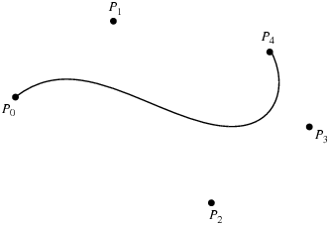

ALGORITHM:
- Get the no of control points n .
- Take the co-ordinates for the n control points.
- To get the intermediate points that lie on the curve use the following equation.
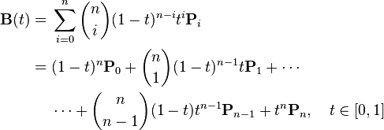
- Plot the points obtained from the above equation.

CONCLUSION:
Thus we have successfully implemented Bezier Curve Algorithm.

